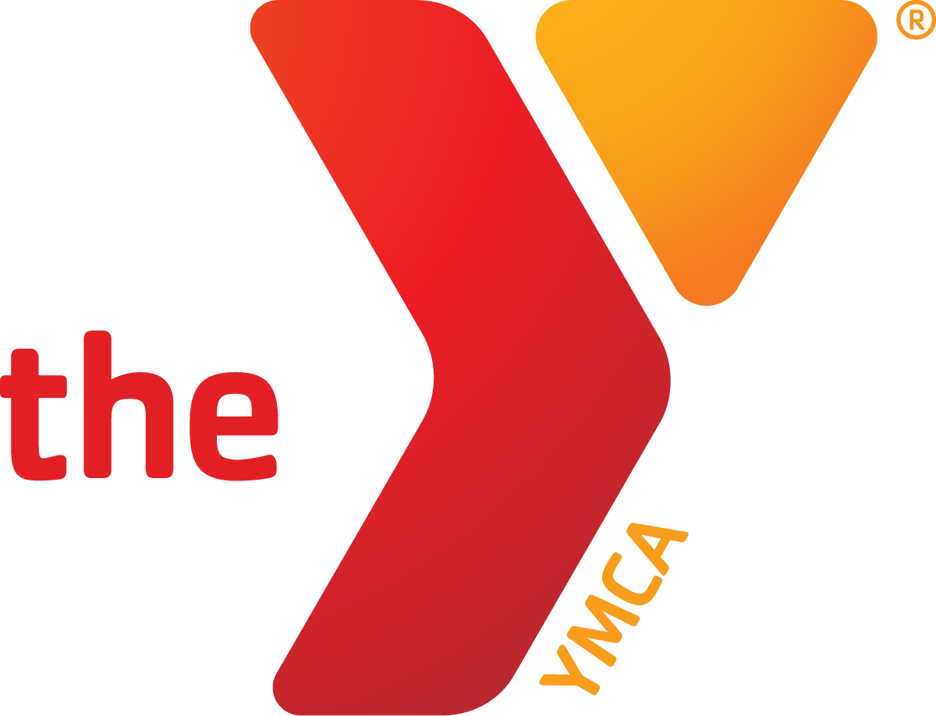
YMCA Youth Soccer Handbook
Updated January 2026

YMCA Sports
YMCA Mission Statement: The FOOTHILLS AREA YMCA is a nonprofit organization whose mission is to put Christian principles into practice through programs that build healthy spirit, mind and body for all.
Youth Sports Philosophy
- Every child plays equally
- Promote the benefits of fitness and healthy lifestyles
- Develop sports skills
- Promote teamwork
- Values education
- Encourage family involvement
- Provide a safe environment
- Improve self-esteem and social development
- Promote character development: Caring, Respect, Honesty, and Responsibility.
Pre-Season
How to Register
You can register online, by phone or in person at the membership desk. Full payment is expected at the time of your registration. Early registration, as well as membership to the YMCA, often provides a discounted rate. Financial assistance is available for families who qualify. If interested, please pick up a financial assistance application from the Member Services desk or online at https://reclique-core-foothills.s3.amazonaws.com/wp-content/uploads/2024/05/07060743/financial-assistance-form-2024.pdf Please allow 7-10 business days for financial assistance approval.
Age of Registrant
Your son or daughters’ age on the first day of their first practice dictates the default division in which he/she will fall. In other words, do not base it on the age your child is at registration, but on the age they will be when the season you are registering for begins.
If your child is an exceptional athlete or is perhaps taller for their age, you may prefer that they “play up” an age division. This is acceptable, but requires special permission from the Sports Director and an over-the-phone or in-person registration. Children are not allowed to “play down” an age division.
Refunds
To request a refund for a sports program, you will need to stop by or call the YMCA Member Services desk. Changes/cancellations can be made for any reason up to 14 days before the program starts.
Once the registration period has closed, refunds or pro-rating will only be issued under unexpected circumstances, such as an injury or a family relocation. Documentation must be provided to consider refund.
Refunds will not be assessed for the following reasons: unhappy with team selection/assignment, weather cancellations, requests not honored, among others.
Coaches
Parent & Community Volunteers
Our coaches are heavily made up of parent and community volunteers. This means they are not paid. It is one of the many ways we keep our prices low and maintain a clear focus on character development. We are always in need of coaches. If you would like to learn more about what it means to be a coach or would like to apply to be a coach, please complete our volunteer application form.
Coaches as Mentors
Your coach is just like you, a parent or caring member of the community who wants to help kids thrive. We ask that our coaches serve not just a coach, but as a leader and mentor for their team. We entrust them to help pass on valuable life lessons and build good character.
Picking a Coach
As implied above under “Registration”, there are no opportunities to request a coach. You may request to be on the same team as another player as family members or for carpooling purposes during registration.
Team without a Coach
If your team has no coach your child’s season will not be cancelled and the team will not be disbanded. By the time the season begins, please know that we have made every effort to find a parent on your team or volunteer to serve as head coach, but that no one has made the formal commitment yet. In this rare occurrence, a YMCA employee will attend the first practice and run it for your team while we continue searching for a coach. In this circumstance, our hope is that a parent or community volunteer will take on the role of head coach and that another will serve as their assistant to fill in when they are unable to.
Communication
Pre-Season
You will begin receiving communication from the sports department two weeks prior to the season beginning. We will be communicating via email regarding team rosters, schedules, weather cancellations, etc. so please ensure you have registered your player with or have an email on your membership account that you plan on checking throughout the season. The emails you receive from the sports staff will have everything you need to know but you can also call the Y for any other questions you may have. The email address you will receive communications from is soccer@faymca.org.
Be sure to check your spam folder as the initial email often ends up there.

In-Season
You will receive a weekly email update from the sports staff from soccer@faymca.org. Any reported issues or changes will be shared via this communication if needed.
Season Logistics & Details
Spring & Fall Locations
Whenever possible we try to keep our sports on campus at your local YMCA. However, that is not always possible. Your child may have practices and games at nearby schools or churches (no more than 20 minutes away from your local branch). Please note that pets and smoking are not allowed at any facility. Please note is not possible for you to choose your location. Locations are pre-determined prior to the season.
Drop Off / Pick Up
A parent or guardian must be present during both practices and games. For the safety and well-being of your child, please stay nearby in case of weather cancellations, emergencies, etc. You are permitted to have another adult chaperone your player. This can be a sibling or other relative as well as caregivers over the age of 16.
Staffing
A YMCA director or coordinator supervises all of our sports. YMCA staff members are required to attend training prior to the beginning of the season, which includes First Aid and CPR training.
Jerseys & Equipment
All athletes will receive a jersey, which will be handed out by the third practice at the latest. We will only provide jerseys for players; they must have their own socks and shorts/pants. As a reminder, everyone should be dressed in comfortable athletic or play attire and should bring a water bottle to stay hydrated and cool. All personal items need to be clearly labeled with the child’s first and last name.

What does my child need at practices and games?
- Shin Guards
- Cleats (soccer cleats) or tennis shoes are acceptable if cleats are not an option
- Athletic bottoms such as shorts and sweatpants (nothing with zippers or buttons)
- Athletic tops such as jerseys, t-shirts or sweatshirts (nothing with zippers or buttons)
- Water bottle (please write your child’s name on it)
- Soccer ball (optional)
- **Please no baseball caps, watches, loop earrings, bracelets or other accessories**

Lost Items
In the event that a personal item becomes misplaced a sports employee will take it inside to the membership desk where it will be placed in the lost and found. Please go inside to the lobby and inquire about your specific item at the Member Services desk. Please provide as much detail as possible if it is not labeled.
Game Days
Please arrive 10 to 15 minutes early to allow ample time for parking, finding the correct field or court and seeing to any last-minute needs prior to the beginning of the game.
Playing Time
All children are guaranteed 50 percent playing time regardless of team size or personal ability. If you believe that your coach is not adhering to this policy, please let our Sports Director know or email soccer@faymca.org. Mistakes do happen, but we will work with you to be sure that they do not become a regular part of your sport experience.
Behavioral Expectations & Guidelines
It is our expectation that children and adults will treat one another with respect and kindness. If a child or adult partakes in bullying, name calling, teasing and other unsportsmanlike conduct they will receive one warning. Following that warning they may be asked to leave the field. It is at the discretion of the site supervisor to determine the severity of the issue. If the problem continues past a single practice or game, it will be at the discretion of the Sports Director to determine a proper course of action which may include ending the season early for a child or prohibiting an adult for further game and practice attendance.
Inclement Weather & Cancellations
It is our intent to get every practice and game in as scheduled, however the safety and well-being of our participants, volunteers, staff and officials is our top priority. Any practice that is cancelled will not be made up. Up to two games can be made up at the end of the season during the final week at your regularly scheduled playing times.
Sunscreen & Bug Spray
In order to comply with our child abuse prevention guidelines, the application of topical products will need to be completed by a parent. Our coaches and staff are not to apply by hand or spray any topical product.
Emergencies
In the event of an emergency, trained YMCA staff will initiate emergency care by activating the chain of survival, which includes calling 911. Emergency care and transportation will be handled by 911 and local emergency services.

Youth Sports Parent Code of Conduct
YMCA Youth Sports Philosophy: YMCA Youth Sports are based on certain beliefs and philosophies: participation and everyone plays. The YMCA encourages having a healthy spirit, mind, and body, meaning the development of the whole person. The YMCA also emphasizes fundamentals, teamwork, fair play, cooperation, and respect for the officials, one’s self, one’s team-mates, and the other team. Our philosophy is simple: EVERYONE PLAYS EVERYONE WINS. Every decision you make and every behavior you display is based first on what you think is best for your athletes, and second, on what can be accomplished to have everyone become a winner.
I hereby pledge to provide positive support, care, and encouragement for my child participating in the Youth Sports Program by following this Parent Code of Conduct:
- I will encourage good sportsmanship by demonstrating positive support for all participants, coaches, and officials.
- I will do my best to make this program fun for my child.
- I will keep winning in perspective. A child usually forgets the outcome of the game: it is the adults that have a tendency to stress the win/loss record.
- I will ask my child to treat other participants, coaches, officials, parents, and spectators with respect
- I will treat officials and coaches with respect. They are there to provide your child with a safe and healthy learning environment. Officials and coaches deserve the same type of environment from the parents and spectators.
- I will strive to be a good role model for my child and the other children in the program. I will encourage my child to learn to lose with dignity and win with grace.
- I will respect my child’s coach and do my best to have my child at all practices and games on time.
- I will recognize the importance of volunteer coaches.
- I realize they are important to the development of my child and the program.
- I will communicate with them and support their decisions.

Season Schedule:

The season schedule will be given out to all families during the parent meeting and emailed the following day. All sessions will be held on Tuesdays and Thursdays with specific days and times for each age group listed on the program page.

Washed-Out Games
- If games are cancelled due to inclement weather, someone will be at the YMCA front desk at least 60 minutes before the first scheduled game with the necessary information.
- A decision will be made 60 minutes before your scheduled game. Each coach to play at that time will be contacted via email with the update.
- All parents will be contacted via email with the update.
  - If you are in doubt of whether your game is cancelled, please contact the YMCA front desk to obtain information.
  - Because it is raining at your location does not necessarily mean it is raining at the YMCA, so please call.
- In the case of bad weather breaking out within 60 minutes of your game or during a game, the Sports Director holds the right to cancel the games. If this happens, the games will be rescheduled on another date by the Sports Director, unless the first half is already completed. If the first half is completed, the game will stand as final.

The current YMCA policy is to schedule 7 games during a season to allow for more skill development with additional practice sessions. We will try our best at rescheduling games unless time/weather restrains us from doing so. We guarantee at least 5 games.

FOOTHILLS AREA YMCA SOCCER RULES
The Ball
- 4-5 age group will use a size 3 ball
- All other divisions will use a size 4 ball
Equipment
- Tennis shoes or soft studded turf shoes recommended.
- Shin guards are required for all divisions.
- Illegal or dangerous apparel:
  - Metal cleats of any type
  - Sharp or badly worn cleats
  - Jewelry, hard hairpieces, exposed buttons, zippers, other hard objects
- Splints or plaster casts are allowed at the discretion of the referee if sufficiently padded
- No pants with exposed buttons or zippers.
- Protective padding: only goalkeepers may wear knee pads and elbow pads in addition to regular uniforms. If a player injury demands support or protection, only properly designed support bandages may be used. No form of padding designed for any other type of support may be worn on the field.
- No hard bill hats.
Starting of the Game
- All players will meet with the referee. The referees which side will kick-off first and then rotate each half/quarter. The defensive team must be outside the center circle on the kick-off.
  - Being Short on Players: If one team shows up at a game with less players than the normal starting number of players, the opposing team will either play down by at most two players or share players on to the other team. (Example of playing down: if it should be 6v6 and the other team shows up with only 4 players, you would only have to play down to 5 players, making it 4v5, or share players to make it 5v5 or 6v6). In the spirit of the Y, we want to make sure all players involved still have a great experience.
  - The opening kick may be played forward or backwards.
Pass back to Goalkeeper (9+)
- When a teammate intentionally passes the ball to the goalkeeper, the goalkeeper may not touch the ball with their hands. If the goalkeeper does touch the ball with their hands, it will result in an indirect free kick at the spot the goalkeeper touched it.

Washed-Out Games
- If games are cancelled due to inclement weather, someone will be at the YMCA front desk at least 60 minutes before the first scheduled game with the necessary information.
- A decision will be made 60 minutes before your scheduled game. Parents will be contacted via email by soccer@faymca.org with the update.
  - If you are in doubt of whether your game is cancelled, please contact the YMCA to obtain information.
  - Because it is raining at your location does not necessarily mean it is raining at the YMCA, so please call.
  - In the case of bad weather breaking out within 60 minutes of your game or during a game, the Sports Director holds the right to cancel the games. If this happens, the games will be rescheduled on another date by the Sports Director, unless the first half is already completed. If the first half is completed, the game will stand as final.
    - Games will be rescheduled at the end of the season, if possible.
    - the current YMCA policy is to schedule 7 games during a season to allow for more skill development with additional practice sessions. We will try our best at rescheduling games unless time/weather restrains us from doing so. We guarantee at least 5 games.
Abandoned Games
- The referee reserves the right at any time to abandon a game (call stoppage of play and leave the field) under the following conditions:
  - A failure by a coach, spectator, or player to heed the warnings given by the referee regarding improper conduct.
  - Extreme climatic conditions in which the playing conditions have become unsuitable, or the possibility of danger exists to players, coaches, spectators, etc.
- If a game is abandoned after the first half is completed, the game will be considered final.
- If a game is abandoned due to climatic conditions before the first half is completed, the game will be rescheduled.
Improper Conduct
- A player or coach may be found guilty of improper conduct. If a referee determines improper conduct by either a player or a coach, he/she will be given one warning via a yellow card.
- The yellow card, to be recorded by the referee, will include the player’s or coach’s name and the team’s name. Two such yellow cards in one game will call for suspension for the rest of the game. Two game suspensions will suspend the player or coach for the remainder of the season.
Spectator Conduct:
- All spectators must remain on the opposite side of their respective teams. Spectators are not permitted behind a goal. “Team Parents” who are assisting the coach with drinks and snacks may sit on the team bench with the coach’s approval.
- Positive team support is encouraged. Offensive language or behavior will not be tolerated. This includes making comments to the officials, players, or coaches.
- The Y is a drug, alcohol, weapons, and tobacco (including e-cigarettes) free zone.
- Each coach is responsible for the conduct of all persons on his/her team or supporting his/her team.
- A spectator may be yellow carded by the referee at which time the official will also notify the coach that a warning has been given to one of their team’s supporters. Further disruptive behavior improper conduct after a second warning will result in a red card (spectator ejection from game) and possible abandonment of the game by the referee.
Entering Field of Play
- No member of the coaching staff may enter the playing area once play is underway, unless invited by the referee. The only exception to this rule will be in an emergency created by player injury.
- 4-5 Year old teams may have one coach on the field during the games.
Possession by a Goalkeeper
- A player shall not charge into the goalkeeper in the penalty area unless the goalkeeper is obstructing the player. Possession or control of the ball includes when the goalkeeper has the ball trapped by either or both hands. Outside the penalty area, the goalkeeper has no more privileges than the other players.
- Goalie Protection Clarification
  - The goalie has possession of the ball whenever he/she catches the ball or holds the ball to the ground with any part of his/her body.
  - Once the goalie gains possession of the ball, no player will be allowed to charge him/her or otherwise obstruct him while he or she is in the process of clearing out the ball.
Fouls & Misconducts
- All fouls outside of the penalty box will result in an indirect free kick from the spot of the foul.
- Ages 9 and older: Fouls, which occur within the penalty box, will result in a penalty kick taken from the penalty spot within the penalty box.
  - The goalie must remain on the goal line until the ball has been struck (the goalie can move side to side not forwards or backwards)
  - Only the goalie, the player taking the penalty shot, and the referee are allowed within the penalty box until the ball has been struck.
  - Once the ball is struck, all players may resume play within the box.

RULE MODIFICATIONS
All age groups:
- All major fouls will result in a stoppage of play, brief instruction or correction, and rapid commencement of play by the offended team.
- Age groups may be adjusted depending on number of players registered in each age group
Play Time: Each player must play a minimum of 2 full quarters per game. The rotation rule does not apply to ages 9-12. However, please try to allow players to experience multiple positions if they would like to. This is a developmental league.
Ages 4-5
- Goalies WILL NOT be used
- Games will be played 3 v 3 (3 players for each team on the field at a time without goalies)
- Game duration: Four, 6-8 min quarters (as determined by coaches, 4 min breaks in between each quarter)
- All out-of-bounds calls will be restarted with a throw-in. Coaches should
- Encourage “two hands over the head, feet down, don’t cross the line.”
- Players may be substituted only on the quarter, half, or for an injury
- There will be referees for these games.

Ages 6-8
- Goalies WILL be used
- Games will be played 5 v 5 (4 players for each team on the field including the goalie)
- There will be referees for these games
- Game duration: Four, 8-10 min quarters (as determined by referees, 4 min breaks in between)
- Players may be substituted only on the quarter, half, or for an injury
- Will use throw-ins, corner kicks, and goal kicks accordingly.
- No player shall play a forward line position or goalie for more than 1 half or 2 quarters per game. No player may play the same position for more than 1 half or 2 quarters in a row. It is the responsibility of the coach to make sure positions are being rotated. Each player must play a minimum of 2 full quarters per game.

Ages 9-12
- Goalies WILL be used
- Games will be played 6 v 6 (6 players for each team on the field including the goalie)
- Game duration: Two, 25 min halves with one 5 min rest in between halves
- Subs can be made on own team’s throw-in, own goal kick, after a goal has been scored, at half, or for an injured player. The opposing teams will be allowed to sub at the same time.
- Will use throw-ins, corner kicks, and goal kicks accordingly.

HEAD INJURY INFORMATION
The USSF has issued a policy removing heading the ball in youth soccer leagues, to help avoid concussion injuries and brain trauma. The Foothills Area YMCA will adopt this policy and eliminate heading in both practices and games for players under the age of 12. A headed ball in a game will result in an indirect free kick for the opposing team at the spot of the foul. A headed ball in the penalty box will NOT result in a penalty kick, but the ball will be placed just outside the penalty box and result in an indirect free kick.

